Revision Labs

Objective
In these series of lab you will
- Create a program to practice many of the pre-course studies

Part 1 – Make a start!
Visual Studio is the development tool used by many C# developers and throughout this course. This lab will show you how to create and run a C# program.

Duration

5 minutes

Step by step

Creating a new Console application using Visual Studio 2022
- Launch Visual Studio and then create a new project 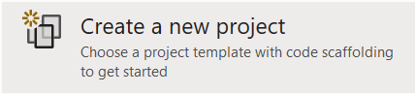
- Select Console app 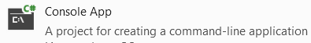 and then Click Next
- Type C:\Labs as the location for your project and type Labs for the name
- You may choose this option if you would like to keep your project and solution file together, but it has little consequence 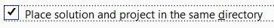
- Click Next
- Select 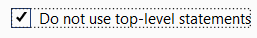for this session so our project layout matches the previous versions of .NET
- Click Create
- A starter code is created for you like
namespace Labs
{
internal class Program
{
static void Main(string[] args)
{
Console.WriteLine("Hello, World!");
}
}
}
- For a cleaner layout and to reduce the number of brackets, hover over the {} icon and then select the first option
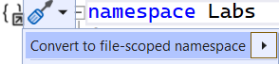
Alternatively, you can change the code manually
namespace Labs;

internal class Program
{
static void Main(string[] args)
{
Console.WriteLine("Hello, World!");
}
}

Building and running the program
- Press Ctrl+F5 to run the program or click the Run icon.
** End of part 1 **

Part 2 - Creating methods
- Add a new method to the Program class and just under the Main method as public static int GetInt(string prompt)
This method displays a prompt (string prompt) and then gets an integer using the Console.ReadLine method, from the user and returns it as an int. (tip: use int.Parse method)
- Create another static method called string GetString(string prompt)
This method displays a prompt (string prompt) and then gets a string from the user which then returns as a string.
- Instead of typing all your code in the Main method, please create another method called Lab1() and call this methoid from the Main methid.
- Call GetInt and GetString methods in the Lab1() method to:
  - Get the user’s age
  - Get the user’s name
  - Display a message that includes the name and age+1 like:
(if Bob is 20 years old) Dear Bob next year you will be 21 years old.

Move your code to a separate class
Does every method have to be in the Program class?
In this part you'll create a new class called Utils and then move the GetInt abd GetString methods to the Utils class.
- Create a new Class called Utils .
Tip: Right mouse click on your project and then select Add > Class menus
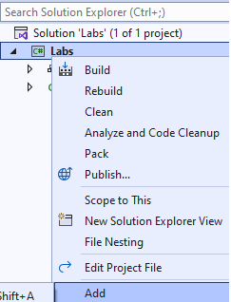
- Transfer the code for the GetInt and GetString methods to the Utils class.
- Remove the static word from every method definition.
We'll discuss static method later. The only reason why every method was static was because the Main() method in the Program class was a static method, but we are now free of static main()!
- At the start of the Lab1() method, create an instance of the Utils class
Utils utils = new Utils();
- At the start of each method call add "utils". For example:
instead of GetInt() type utils.GetInt()
- Run the application to make sure everything works.

** End of Part 2 **

Part 3 - Practice IF statements
In this part you will calculate the amount of Life insurance
- Comment out the code in part 1 & 2.
- Create a new Class called LifeInsurance.
- Create a new method in the LifeInsurance class called Calculate with no parameters which returns a double value like public double Calculate()
- Your Lab1() method will call the calculate method like:
(please comment out any previous code)
LifeInsurance life = new LifeInsurance(); Console.WriteLine(life.Calculate());
- The LifeInsurance’s Calculate method code:
  - Ask the user for their name and age.
Only accept ages from 18 to 75 inclusive.
If the age is outside this range, display an appropriate message and return the value -1.
  - Ask the user how many years they want the life insurance to run.
The duration must be between 10 and 25 inclusive.
Older customers may not be able to take the full term they ask for.
The maximum term is calculated as 85 minus the customer’s age.
For example, a person who is 70 can only choose a term of up to 15 years because 70 + 15 equals 85.
  - Ask the user for their occupation.
Apply a ten 10% discount for nurses, doctors, teachers, or police officers.
  - Use the following formula to calculate the payment.
Minimum payment of £5 plus the age plus the term divided by ten.
Apply any discount and return the final amount.
*** End part 3 ***

Part 4 - Practice an Iteration statement (loops)
In this part you will calculate the amount of Life insurance

- Create a for loop in the Lab1() method, execute the line containing life.Calculate(); 3 times.
- Replace the for loop with a while loop.
- Test you code to make sure it works
- Within the while loop ask the user if they would like to calculate another quote and break out of the loop if they say No!
*** End of the Revision exercises ***

